***1.INTRODUCTION***:

1.1 Overview

This method is suitable for large and old city with considerable development. If it is used for small,average or comparatively new cities,it will give low result than actual value. In this method the average increase in population per decade is calculated from the past census reports.This increase added to the present population to find out the population of the next decade.

1.2 Purpose

A Population projection gives a picture of what the future size and structure of the population by the sex and age might look like.it is based on knowledge of the past trends,future on assumption made for three components.

**2. PROBLEM DEFINITION&DESIGN THINKING:**

2.1 Empathy map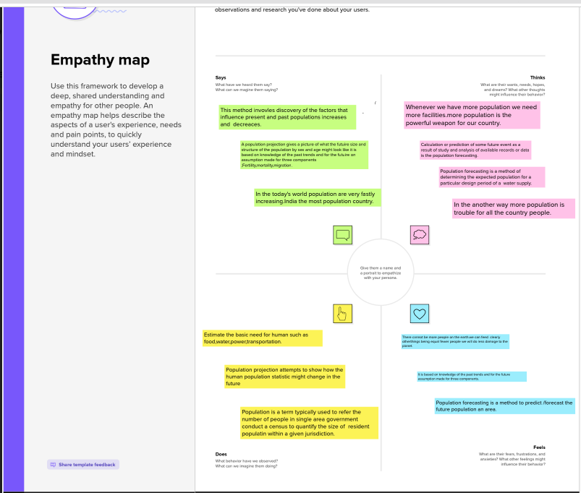

2.2 Ideation & Brainstroming map

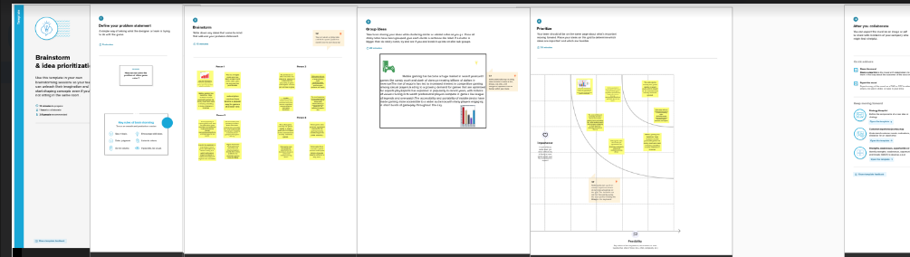

**3.RESULT**

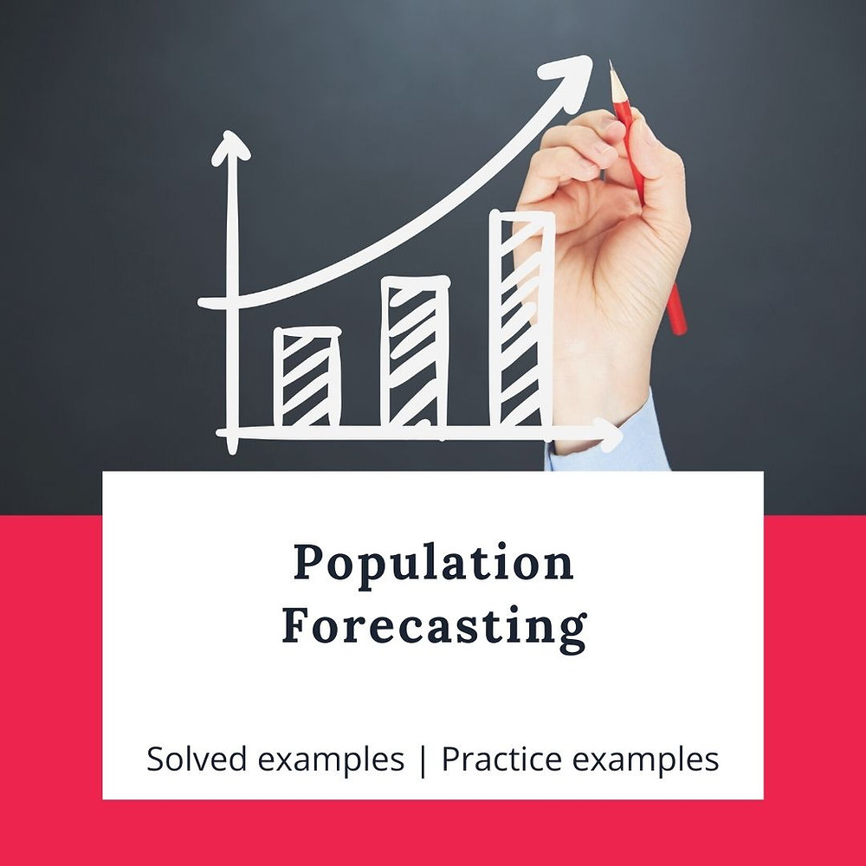

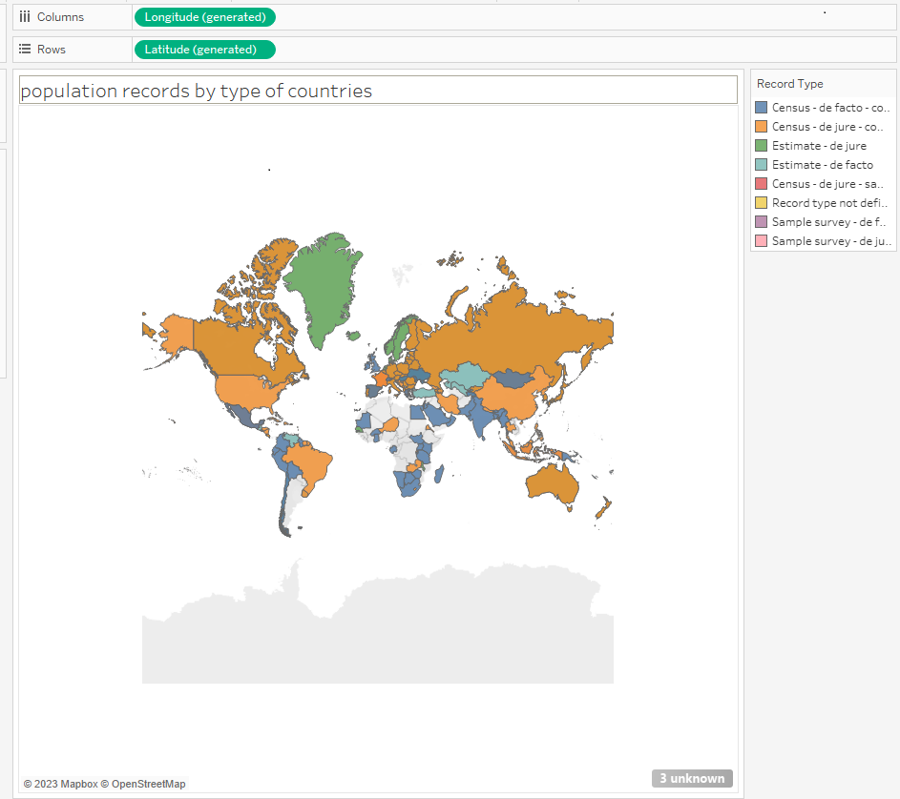

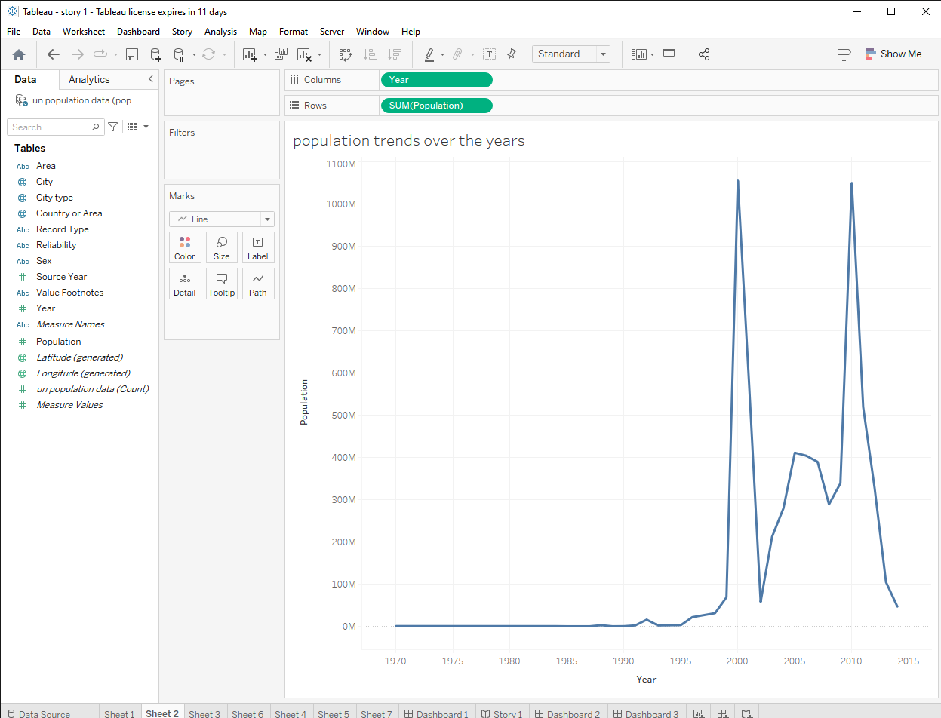

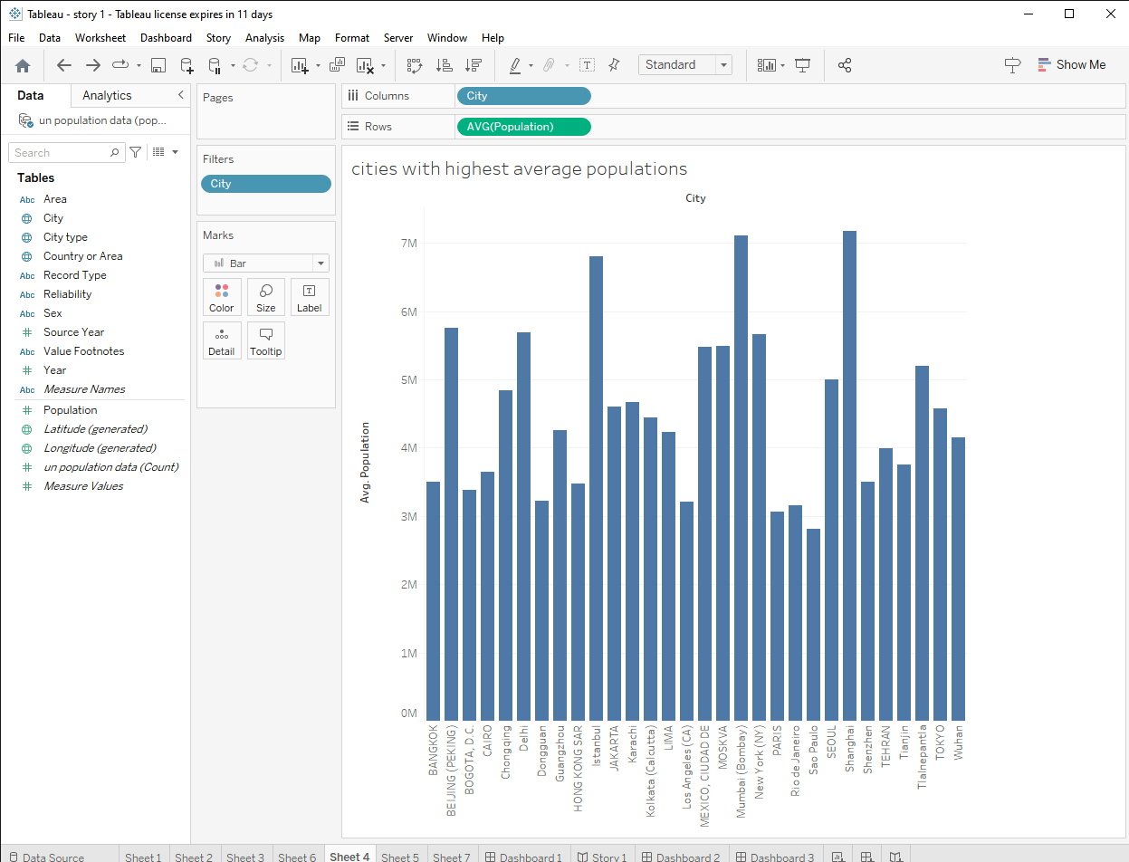

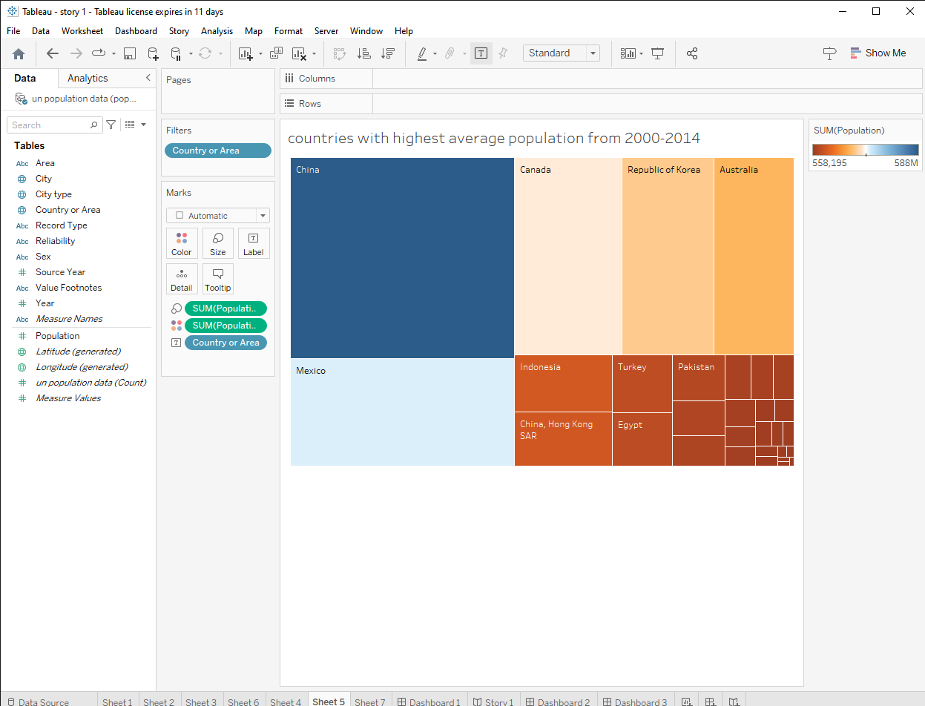

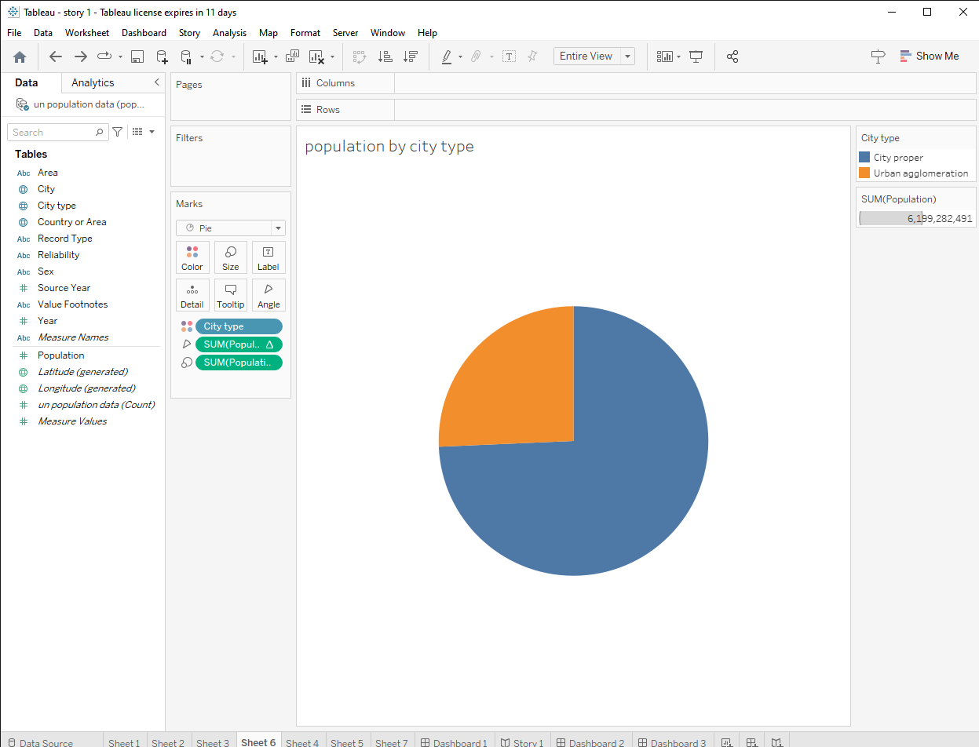

**4.ADVANTAGES & DISADVANTAGES**

**Advantages:**

* **More people leads to greater human capital..**
* **Higher economic growth…**
* **Economies of scale..**
* **The efficiency of higher population density…**
* **The improved demographic structure of society..**
* **Critical mass..**
* **Cost to the environment..**
* **Congestion.**

**Disadvantages:**

* **Cost to the environment. Population growth exacerbates many of the existing environment problems..**
* **Congestion .Too many people in a small space will lead to various types of congestion..**
* **Water shortage…**
* **Generating unsustainable waste.**

**5. APPLICATIONS**

**Basically ,there are three techniques for population projection :**

**\*Mathematical methods , economic method and cohort method.mathematical method is frequently used for the estimate of population.it is done for short period.**

**6. CONCLUSION**

**This is the modern method of forecasting population. In this method the master plans are prepared for the development of the cities in 30-40 years.the population densities for the various zones are fixed for future development.**

**7. FUTURE SCOPE**

The world Population continues to grow,but the pace of growth is a slowing down.The world Population is projected to reach 8 billion on 15 november 2022.

**8.APPENDIX :**

**1.<https://public.tableau.com/views/book3_16828342246650/story1?:language=en-US&publish=yes&:display_count=n&:origin=viz_share_link>**

**2.https://public.tableau.com/views/book4_16828346637490/Dashboard1?:language=en-US&publish=yes&:display_count=n&:origin=viz_share_link**